Title in English (Times New Roman; size-12; Interline 1,15)
العـنـوان باللغة العربية (الخط: Traditional Arabic، حجم الخط 12، تباعد أسطر 1,15)

Full name of the first author ^{1*}, Full name of the second author ²
¹ Full affiliation, Email address, (Times New Roman; size-12)
² Full affiliation, Email address, (times new roman; size-12)

Date of receipt: Date of revision: Date of acceptation:
Abstract
ملخص

ضع الملخص هنا  الملخص لا يجب أم يتعدى 250 كلمة حيث يتم الإشارة فيه إلى هدف البحث، و أهم النتائج المتوصل إليها في فقرتين.  الملخص لا يجب أم يتعدى 250 كلمة حيث يتم الإشارة فيه إلى هدف البحث، و أهم النتائج المتوصل إليها في فقرتين.  الكلمات المفتاحية: ك م، ك م، ك م، ك م، ك م، ك م. | Enter your abstract here  The abstract should not exceed 250 words where reference to the goal of the research, and the most important results reached in two paragraphs.  The abstract should not exceed 250 words where reference to the goal of the research, and the most important results reached in two paragraphs.  Keywords : Keywords, Keywords, Keywords, Keywords, Keywords, Keywords.  .
* Corresponding Author: Name and Surname, Email: authorC@yahoo.com

1. INTRODUCTION

2. First Subtitle
The first subtitle opens with an introduction that presents the specific problem under study and describes the research strategy. The first subtitle opens with an introduction that presents the specific problem under study and describes the research strategy. The first subtitle opens with an introduction that presents the specific problem under study and describes the research strategy.
3. Second Subtitle
Enter here the text of second subtitle, enter here the text of second subtitle, enter here the text of second subtitle, enter here the text of second subtitle, enter here the text of second subtitle, enter here the text of second subtitle, enter here the text of second subtitle, enter here the text of second subtitle, enter here the text of second subtitle, enter here the text of second subtitle, enter here the text of second subtitle, enter here the text of second subtitle, enter here the text of second subtitle.

4. RESULTS AND DISCUSSION
Enter your results in this section, summarize the collected data and the analysis performed on those data relevant to the discourse that is to follow. After presenting the results, you are in a position to evaluate and interpret their implications, especially with respect to your original hypotheses.

Table 1. Table title (this is an example of table 1)
Test 1 | Test 2 | Results 1 | Results 2 | Total Results
15.21 | 15.21 | 15.21 | 15.21 | 15.21
18.58 | 18.58 | 18.58 | 18.58 | 18.58
11.14 | 11.14 | 11.14 | 11.14 | 11.14

Source: author’s name, year, page

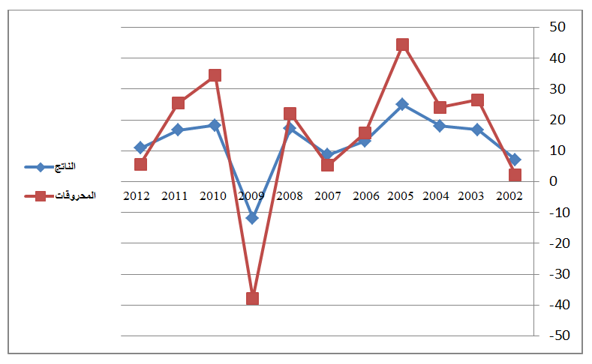
Fig.1. Figure title (this is an example of figure 1)

Source: author’s name, year, page

3. EXPERIMENTAL
This experimental section can be divided into subsections, the contents of which vary according to the subject matter of the article. It must contain all the information about the experimental procedure and materials used to carry out experiments.

4. CONCLUSION
The conclusion of a research paper needs to summarize the content and purpose of the article. The conclusion of a research paper needs to summarize the content and purpose of the article. The conclusion of a research paper needs to summarize the content and purpose of the article. The conclusion of a research paper needs to summarize the content and purpose of the article. The conclusion of a research paper needs to summarize the content and purpose of the article. The conclusion of a research paper needs to summarize the content and purpose of the article.

5. Bibliography List :
Use the « APA Reference System », see the link :
https://support.office.com/fr-fr/article/APA-MLA-Chicago-%E2%80%93-Mise-en-forme-automatique-de-bibliographies-405c207c-7070-42fa-91e7-eaf064b14dbb
The references must be directly quoted in the body of the text (eg: ... (Brown, 2006, p35), without omitting to mention the complete reference in the list of references at the end of the document, written in the following manner: (Times New Roman12 interligne 1.15)
- Books : author’s name (year), full title, publishing, country;
- Journal article : author’s name (year), full title of the article, review name, place, volume and number ;
- Seminar article: author’s name (year), full title of the paper, title of seminar, place and date, country ;
- Internet websites: author’s name (year), full title of the file, detailed website : http://fulladdress (consulted on day/moonth/year).

6. Appendices

Important Notes : The volume of the research article should not exceed 20 pages.

