Title of the article, Times New Roman, Size 12, Bold, Interline 1

Name and Surname^{1,*}, Name and Surname², Name and Surname³
¹ Full affiliation (Country), Times New Roman 12, Interline 1
² Full affiliation (Country), Times New Roman 12, Interline 1
³ Full affiliation (Country), Times New Roman 12, Interline 1

Received: Day/Month/Year ; Revised: Day/Month/Year ; Accepted: Day/Month/Year

Summary: Enter the summary here in this frame (the abstract should not exceed a maximum of 200 words); The summary should be concise, focused and encompassing the main content of the article, without specifying details. The researcher presents the purpose of the research, namely its objective (the problem posed in this research), the methodology of the work and the tools used. Also, expose the major results. The researcher must avoid inclusion in the abstract: citation, orientation to another reference, use of abbreviations (...., Etc.); the use of incomplete sentences, the use of ambiguous terms, the use of any form of graphs or tables.

Use of Times New Roman font in the title, size 12, bold, interline spacing 0.88, and font type in Times New Roman text, size 12, interline spacing 0.88 (this format applies to words keys). The summary is followed by keywords as cited in the article and (Times New Roman font, size 12, 0.88 interline spacing).

To note, taking into account not to exceed 5 keywords, undefined and following the JEL classification of the article, and for more details on this classification see: http://en.wikipedia.org/wiki/

Keywords: Keyword ; Keyword ; Keyword ; Keyword ; Keyword.
Jel Classification Codes : XNN ; XNN

I- Introduction:

The text of the boot is written in Times New Roman, size 12, the inter lines spacing 0.88 (of course, this format applies to all textual texts); the author of the article considers both the general and specific side of the subject to provide information that describes the problem accurately. Rationale of the subject should be presented in a form of a question the problem in the form of only one question, and the hypothesis/hypotheses underlying it (the possible outcome of the solution), in addition to the previous research and studies that dealt with the subject directly related, and written in a sequential and concise scientific way through which the researcher shows similarities and differences in terms of purpose, Sample study, variables, method and tools used, then the conclusions reached.

I.1.First Subtitle
Enter here the content of the text of the first subtitle in the same format (font, size, interlines spacing). Enter here the content of the text of the first subtitle in the same format (font, size, interlines spacing). Enter here the content of the text of the first subtitle in the same format (font, size, interlines spacing). Enter here the content of the text of the first subtitle in the same format (font, size, interlines spacing).

___________________________
* Corresponding author, e-mail: ^{authorC@mail.com}
I. 2. Second Subtitle:
Enter here the content of the text of the first subtitle in the same format (font, size, interlines spacing). Enter here the content of the text of the first subtitle in the same format (font, size, interlines spacing). Enter here the content of the text of the first subtitle in the same format (font, size, interlines spacing). Enter here the content of the text of the first subtitle in the same format (font, size, interlines spacing).

II –Methods and Materials:
The author of the article in this section explains clearly how to select the sample, determine the variables and how to measure them, how to collect the data and describe how the data are summarized (average, percentage, …), Statistical and standard tools used in data analysis, hypothesis testing and statistical significance. Sometimes it may be necessary to mention the programs used in the calculation. When using a method previously used and published by another researcher, must be referred to as marginalization without being re-described, Though There are changes in the method, which must be explained and explained.

These methods and tools must be presented precisely and clearly without exaggeration so that other researchers can re-examine or verify them. The author can describe the tools and methods used in the form of a scheme, table or diagram to explain methods used, This section is divided into sub-sections, where its contents vary according to the subject matter of the article.

III- Results and discussion:

Enter your results in this section in the same format (font, size, dimension between lines). A summary of the collected data should be presented in the proportions or totals form, then review the analysis conducted on the collected data using both text and illustrative means In the Appendix) in accordance with the method and tools reviewed above. After presenting the results, their contents can be evaluated and interpreted statistically in the light of the hypotheses and compared with previous studies results.

IV- Conclusion:

Enter the article abstract here in the same format (font, size, distance between lines). Considers the main conclusions and deductions of the previous section that answer the question in the introduction, followed by the proposals made through the field study, The abstract of the article includes the theoretical and practical limits of the research (self-criticism: reflect author future research intentions.

- Appendices:

Include data and information not necessary for inclusion within the text, which provide important explanatory information to understand the article, and information that can be included in the annexes, for example: raw data; questionnaires; graphs, tables, and diagrams (New Times Roman12; The interlines spacing lines 0.88).

Table (1) : Table title
Test 1 | Test 2 | Factor 1 | Factor 2 | Coefficient
15.21 | 15.21 | 15.21 | 15.21 | 15.21
18.58 | 18.58 | 18.58 | 18.58 | 18.58
28.05 | 28.05 | 28.05 | 28.05 | 28.05
11.14 | 11.14 | 11.14 | 11.14 | 11.14

The source :…………………………….

Figure (2): The Figure Title  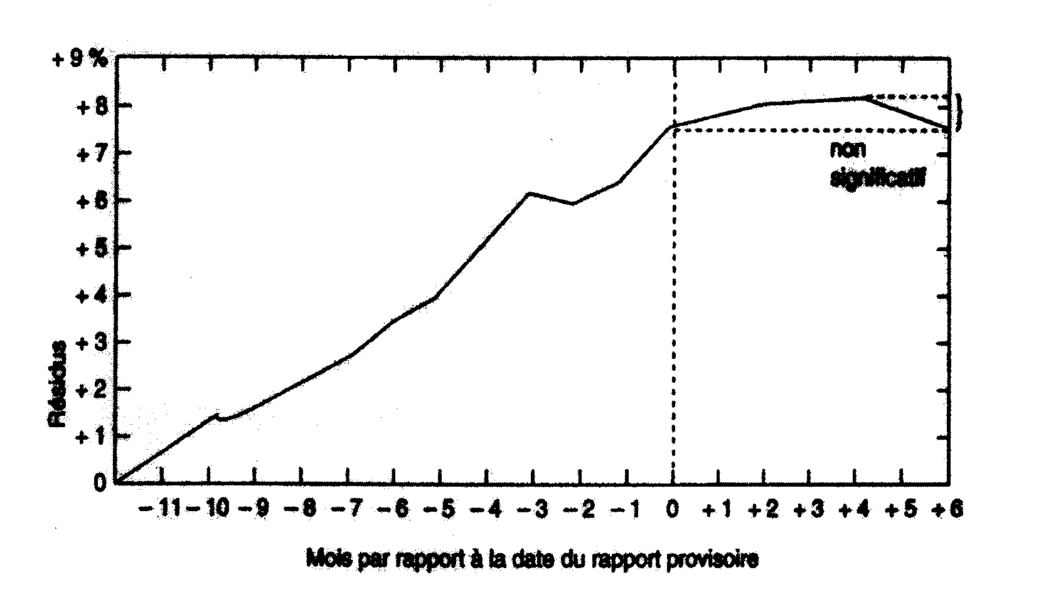  The source :……………………. |  | Figure (1): The Figure Title  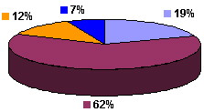  The source :…………………………….

-
Referrals and references:
Considers Times New Roman font, size 12, and interlines spacing 0.88, and a space before the reference. The bibliographic sources of the scientific material in the article are only those from which quotations are made, and precise exactly page / The referrals and references are arranged sequentially as they appear in the text of the text, and are all listed according to the American Psychological Association (APA) method as follows:

- Abdelaziz Naoum (2017), determinants of economic growth in Algeria in the long term for the period (1970-2013), El-bahith review, 17 (17), Algeria: University of Kasdi Merbah Ouargla, PP225-235, Visited:15/05/2017, https://www.asjp.cerist.dz/en/article/34428 (Written in Arabic).
Ahmed Al-Ashqar (2002), Macroeconomics, First Edition, Amman: International Scientific Publishing House, p.290 (Written in Arabic).
Djeflat Abdelkader (2004), "La fonction veille technologique dans la dynamique de transfert de technologie : rôle, importance et perspectives", Alger : CERIST, P19. 3 RENARD V. (2005). « Marché foncier », in Dictionnaire de l’urbanisme et de l’aménagement, sous la direction de Pierre Merlin et François Choay, ; Paris : Ed PUF coll. Quadrige.
Tarek TAHA (2017), Forecasting Fire Insurance Loss Ratio in Misr Insurance Company. El-bahith review (17)17, Algeria: University of Kasdi Merbah Ouargla, 31-39. Visited:20/10/2017, https://www.asjp.cerist.dz/en/article/34449
Tarig, Y.A., Moayad, M.A. and Ala, M.R. (2013). The role of forensic accounting in reducing financial corruption: A study in Iraq. International Journal of Business and Management. 9(1), pp.26–34. Note: The maximum number of pages of the paper, is 16 pages. How to cite this article by the APA method: Author 1, Author 2 and Author 3 (2018), Title of the article, Algerian review of economic development, Volume XX (Number XX), Algeria: Kasdi Marbah University Ouargla, pp. 1-3.

